CENTRE FOR ENVIORNMENT TECHNOLOGY AND RURAL DEVELOPMENT
P.O,BOX 259
KASESE UGANDA
Tel 256 772 466461
Email cetrud@yahoo.com and godfreydembekasozi@gmail.com
Santa Cruz Sunrise Rotary contact Peggy Pollard, ISI.SantaCruz@gmail.com

KARUSANDARA DRAUGHT AND WATER PUMPING PROJECT

This project presents the work devoted to the assessment of available technology and management options for the wide-scale implementation of community water supply systems, which range from water pumping to crude community water irrigation directing water from the river.

Recently we discovered that due to the long draught the water needs have increased for Karusandara and neighboring area in order for the community to be economically stable and to grow food crops that can both be sold at market and for their own consumption. This can be achieved if the proposed community water pumping system is in place.

PROJECT DETAILS: purchase of a low cost community water pump $1,700 (see specs below) and replacement seeds.

BUDGET for project $ 3,500 dollars (approx as of last week)
$ 1,500 – pump and pipes 500 meters of pipes (actual pump cost $1,700 plus tax?)
$ 500 Fuel and oils and spares for both pumps
$ 1,500 --Draught resistance seeds of maize , beans yams and Pineapple suckers
= $ 3,500 TOTAL
DESCRIPTION:
Pump with pipes that will run 800 meters in three villages of Karusandara, Kylanga and Kabaka which are all in in the sub-county of Karusandara. The area directly served by the pump has 4,000 people.

An additional 3,000 people will indirectly benefit in the neighboring area by being able to buy the food grown from the crops grown in the project area. For a total of 7,000 people benefitting from the water pump project, both men, women and children.

Source of water is on river Sebwe, and another source is on river Kabaka and the man made channel at CETRUD demonstration garden that runs 500 metres

The map of the area to be served :
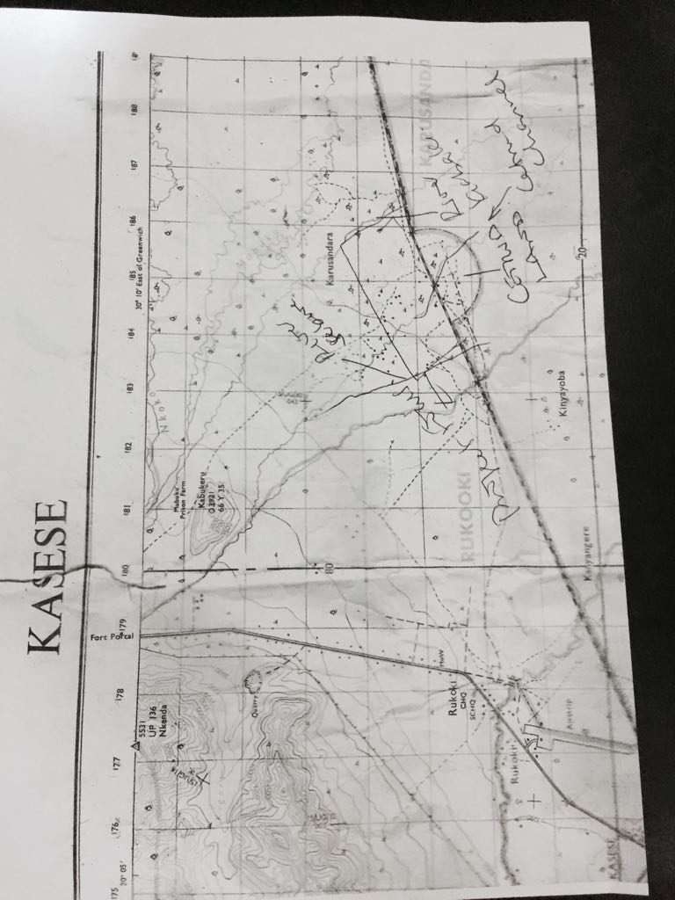
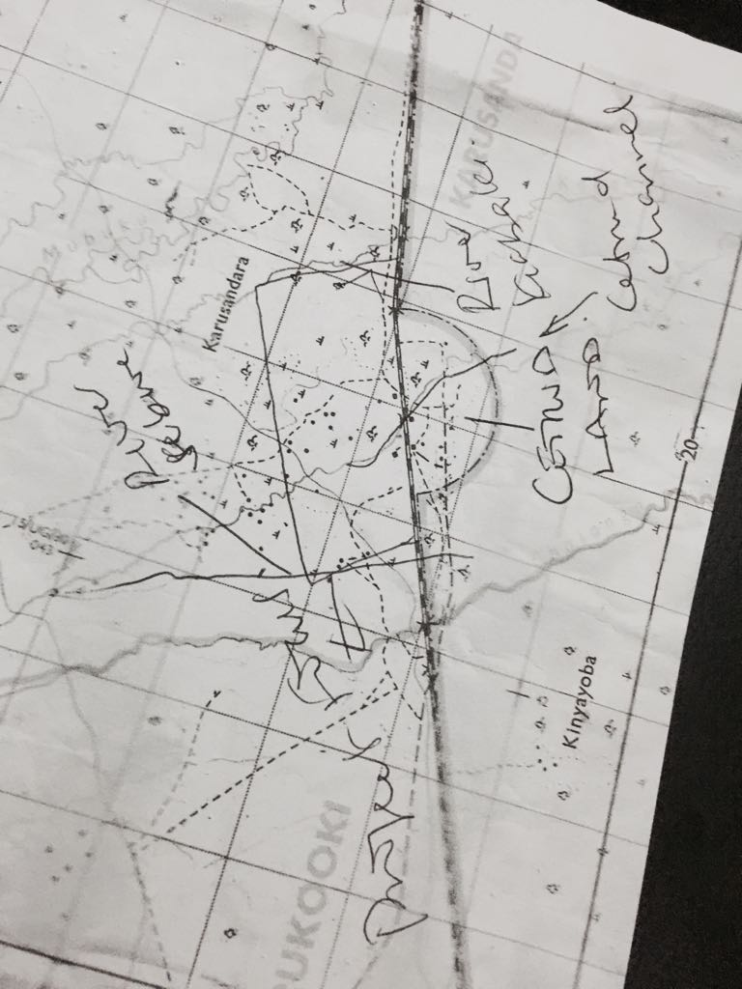
Karusandara Map closeup

Karusandara is the Sub-county of Kasese region most affected by the draught due to the long spell that has taken place from June up to now, instead of our normal seasonal heavy rains.

Most of the affected farmers have land owned by their individual family, under the name of CETRUD (area outlined shown on map as a rectangle & half circle) within three hundred acres with a population of 1,200 people. The community of farmers own the land, but they acquired it with the help of CETRUD.

The rest of the 4,000 people receiving water from the project are from the neighboring villages around CETRUD land

KARUSANDARA BACKGROUND
An adequate water supply is one of the basic needs of life, but is often lacking in this community of Karusandara in Kasese district. Therefore, we have been continuously asking our regional government to provide water to Karusandara area for consumption and production.

This innovative water pump project, is part of an overall objective of empowering our minority tribes in Karusandara, who have been marginalized community members. The project will help transform them from vulnerable groups into a developing society. This new resource is also an enhancement of socioeconomic development through improved water supply by pumping the water source into Karusandara’s local water channels. This project will improve livelihood through ensuring higher income by using the water pumped to the community during the more frequently occurring draught season.

The type of pump to be purchased

Honda Self-Priming Construction Trash Water Pump — 3in. Ports, 19,140 GPH, 1 1/16in. Solids Capacity, 240cc Honda GX240 Engine, Model# WT30XK3A

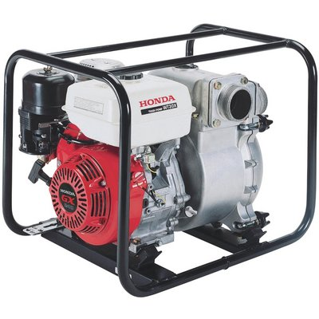

- Price $1730
- Durable Honda GX series commercial grade engine is easy starting and provides ample power for the toughest conditions
- Heavy duty full frame protection protects the pump, while offering a convenient tie down location for transport
- Easy access service port makes clean-out quick
- Replaceable stainless steel wear plate increases durability while reducing maintenance costs
- Includes a convenient multi-tool for easy removal and installation of the pump case, for tightening and removal of the priming plug and drain plug and for tightening and removal of the hose coupling

Product Summary
This Honda Self-Priming Construction Trash Water Pump is powered by a powerful Honda GX240 OHV 240cc engine with Oil Alert®. Designed for use on job sites and other applications where high-volume trash water capacity is needed. Built to last with durable silicon carbide mechanical seals and a cast iron volute and impeller.

Features + Benefits
- Durable Honda GX series commercial grade engine is easy starting and provides ample power for the toughest conditions
- Heavy duty full frame protection protects the pump, while offering a convenient tie down location for transport
- Easy access service port makes clean-out quick
- Replaceable stainless steel wear plate increases durability while reducing maintenance costs
- Includes a convenient multi-tool for easy removal and installation of the pump case, for tightening and removal of the priming plug and drain plug and for tightening and removal of the hose coupling
- Abrasion-resistant silicone-carbide seals for extended wear
- Rigid-mount cast iron volute reduces case wear for increased pump life
- Isolation-mounted engine and pump minimize vibration, keeping the pump from "walking" away or "burying" itself in soft soil conditions and reduces wear on components
- Unique conical impeller shape improves priming and higher discharge capacity with wide vanes that are designed to resist wear and maximize durability
- Honda Oil Alert protects the pump by shutting the engine off when low oil is detected
- Large heavy duty steel strainer allow solids up to 1 1/16in. solids to pass through, as well as a large volume of water, helping to prevent clogging

Key Specs
Item# | 109403
Manufacturer's Warranty | 3 year limited warranty
Ship Weight | 140.0 lbs
Fits Hose Dia. (in.) | 3
Engine Displacement (cc) | 270
Flow (GPH) | 19,140
Engine | Honda GX240
Engine Type | OHV
Max. PSI | 39
Suction Port (in.) | 3
Discharge Port (in.) | 3

Max. Suction Lift (ft.) | 26
Max. Total Head (ft.) | 89
Self-Priming | Yes
Solid Handling (in.) | 1 1/16
Seals | Silicon carbide mechanical
Impellers | Conical cast iron
Volute | Cast iron
Start Type | Recoil
Low Oil Shutdown | Yes

