**Saturday June 8, 4 p.m.**

**Farewell Reception for**

**Friendship City Delegation**

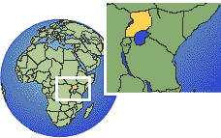**from Kasese, Uganda**

**MC900161802[1].wmf@ private home in Santa Cruz**

**BYOB & dish, and your friendship to share!**

**RSVP to Peggy 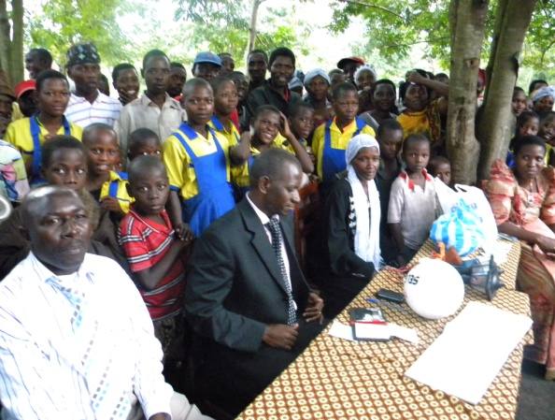 ISI.SantaCruz@gmail.com (831) 239-3429**

June 1-11, Kasese government and business leaders visit Santa Cruz to kick off our Sister City relationship.

***DELEGATES speak 5 p.m. --***

* Godfrey Dembe Kasozi – Exec. Director CETRUD
* Godfrey Baluku Kime Kabbyanga -- Mayor of Kasese
* Felix Alex Majeme – Town Clerk of Kasese
* Ritah Akiiki Khan – Director Rwenzori Cotton Ginners Co. Ltd.
* Caroline Nsubuga – Past President, Rotary Club of Kasese

**Peggy Pollard,** Santa Cruz Sister City Committee**,** Kasese, Uganda subcommittee

ISI.SantaCruz@gmail.com (831) 239-3429 [www.Kasese-SantaCruz.weebly.com](http://www.Kasese-SantaCruz.weebly.com) http://www.cityofsantacruz.com/index.aspx?page=712

**"like" us on Facebook:** Friends of Kasese, Uganda - Santa Cruz, California Sister Cities <https://www.facebook.com/KaseseSantaCruz>

**DELEGATION SCHEDULE June 1-11** (Godfrey Kasozi 5/29-6/27)

<https://docs.google.com/spreadsheet/ccc?key=0Ai2eDa9Tw3CMdFlHNmtPX05XbVlJZFBuYTBWRUIwRWc&usp=sharing>

Sponsored by the Santa Cruz Sister City, Kasese subcommittee “Friends of Kasese”