Santa Cruz Sister Cities announces
Kasese, Uganda “Friendship City” delegation visits Santa Cruz June 1-11
Five government and community leaders from Kasese, Uganda are visiting the City of Santa Cruz as part of the two-year trial phase for their city to become a Sister City to the City of Santa Cruz.
- Godfrey Kasozi, Director of Kasese’s CETRUD (Center for Environment Technology and Rural Development) is a 1999 graduate of UCSC’s “Farm” internship, CASFS (Center for AgroEcology and Sustainable Food Systems). Kasozi trains 2,000 Ugandan farmers a year in organic farming as well as other educational and economic programs.
- Godfrey Kabbyanga -- Kasese Mayor
- Carol Nsuguba -- Past President of Kasese Rotary
- Felix Majeme – Town Clerk of Kasese
- Ritah Khan – Director Rwenzori Cotton Ginners Co. Ltd.

Sister Cities will host four public receptions to welcome the delegation (schedule below). The delegates will visit local government, university ,businesses and other agencies in their 9-day visit.

In May, the Kasese region suffered their worst flooding in decades, due to three rivers overflowing. Red Cross estimated 25,455 people affected and thousands homeless. Sister Cities has been doing fundraising for flood disaster relief. Click for Sentinel News Story http://www.santacruzsentinel.com/localnews/ci_23252853/volunteers-seek-relief-friendship-city-santa-cruz?IADID=Search-www.santacruzsentinel.com-www.santacruzsentinel.com

For more information contact Sister Cities, Kasese subcommittee chair Peggy Pollard. ISI.SantaCruz@gmail.com (831) 239-3429 Facebook: “KaseseSantaCruz”
www.Kasese-SantaCruz.weebly.com http://www.cityofsantacruz.com/index.aspx?page=712
DELEGATION SCHEDULE June 1-11 (Godfrey Kasozi 5/29-6/27)
https://docs.google.com/spreadsheet/ccc?key=0Ai2eDa9Tw3CMdFlHNmtPX05XbVlJZFBuYTBWRUIwRWc&usp=sharing
Public Receptions for Kasese Delegation
6/1, Saturday (SFO pickup 2 p.m.) ? 5-7 pm. welcome BBQ @ Pollard home 128 Monterey St. Santa Cruz
6/3, Monday, 10:30-11:15 Santa Cruz Mayor’s reception @ City Hall Patio
6/7, Friday, 6-8 p.m. Theater program “Taste of Africa” @ Cabrillo College Black Box Theater, FREE
6/8, Saturday, 4 p.m. Farewell Reception @ private home Santa Cruz RSVP to Peggy BYOB & dish of food
The delegation will also attend Sunrise Rotary June 4 and 11, speak at Scotts Valley Rotary June 10, and visiting SC Rotary @Elks Lodge Friday June 7
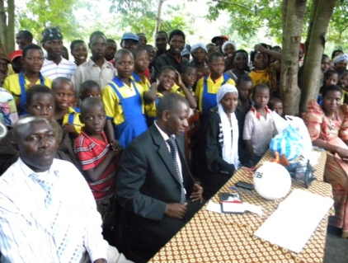
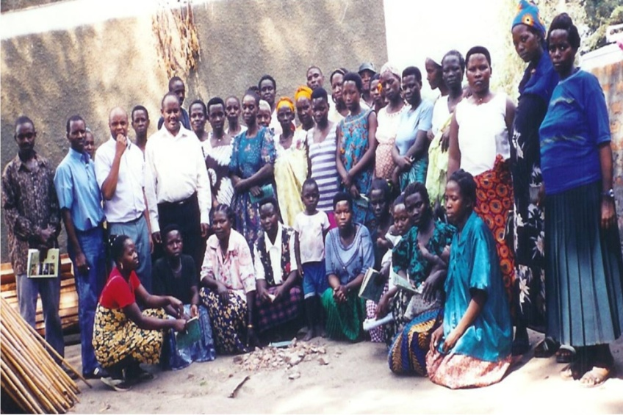
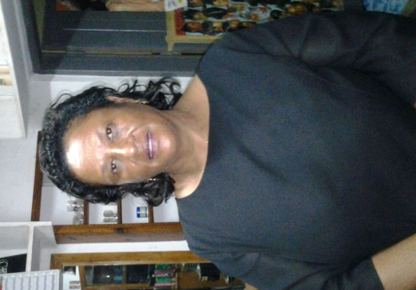
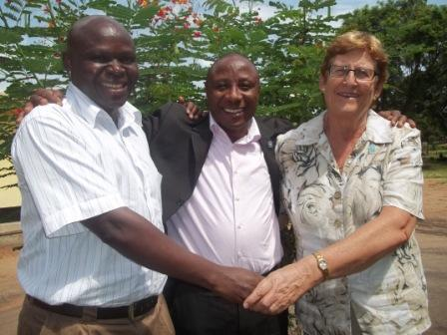
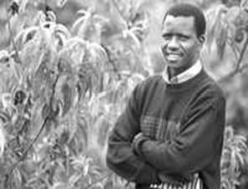
Godfrey (center) and people of Kasese
Godfrey Kaozi and Kasese residents
Godfrey Kasozi, portrait by Bill Lovejoy, SC Sentinel
L to R, Godfrey Kabbyanga, Felix Mujemi , Carol Nsubuga
Ritah Khan, Director Rwenzori Cotton Ginners, Co. Ltd.

