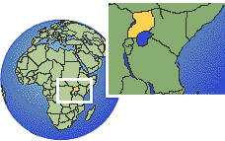**MC900161802[1].wmfSanta Cruz Sister Cities invites our community**

**Friday June 7, 6-8 p.m.**

**Meet the Heroes of Kasese!**

**Taste of Africa**

Join us for a **FREE** evening of arts, entertainment and refreshments to welcome the first **Friendship City Delegation**

**from Kasese, Uganda**

**@ Cabrillo College Black Box Theater & Lobby (right side of Crocker Theater)**

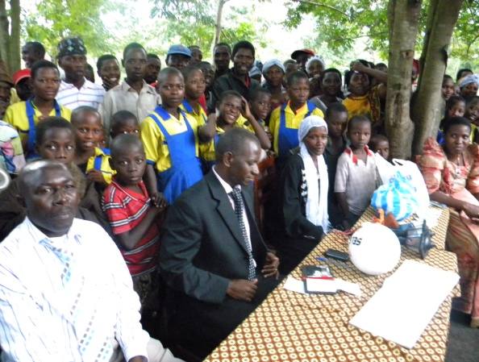Artists: **6500 Soquel Dr. Aptos, CA 95003 831/479-6100**

**Jim Greiner "Hands-on Drumming"**

**Charlie Tweedle**

**Rainbow Theatre**

**Fashion Show: Jeannie Collins & Dancers**

**Uganda inspirations & fabrics**

**Event Coordinator: Donald L. Grube**

June 1-11, Kasese delegation of government and business leaders visit Santa Cruz to kick off Sister City economic, cultural and educational exchanges. Share ideas and inspirations as these survivors meet the challenge to raise Kasese from the ruins of the worst flood in over 43 years affecting over 25,445 people.

* **Godfrey Kabbyanga** -- Mayor of Kasese
* **Felix Majeme** – Town Clerk of Kasese
* **Ritah Khan** – Director Rwenzori Cotton Ginners Co. Ltd.
* **Caroline Nsubuga** – Past President, Rotary Club of Kasese
* **Godfrey Kasozi** – UCSC “Farm” CASFS alumni, Exec. Director CETRUD Center for Environment Technology and Rural Development in Kasese -- an innovative permaculture farm and community, a leader for a more sustainable Kasese. [www.CETRUD.org](http://www.CETRUD.org)

Santa Cruz Sister Cities, Kasese, Uganda subcommitteeISI.SantaCruz@gmail.com (831) 239-3429

[www.Kasese-SantaCruz.weebly.com](http://www.Kasese-SantaCruz.weebly.com) **"like" us on Facebook:** [www.facebook.com/KaseseSantaCruz](https://www.facebook.com/KaseseSantaCruz)